**“Experiment 6: Harmonic Oscillator, Part II: Physical Pendulum”**

**“Experiment 7: Waves on a Vibrating String”**

Christina Oliveira; UID: 204-803-448

November 14 2017; November 28 2017

Tuesday 9AM

TA: Paokuan Chin

Lab Partner: Rosanna Rico

Abstract Word Count: 170

**Comparisons of Theoretical and Experimental Oscillation Data: Physical Pendulum and Waves on a String**

C. Oliveira1

**ABSTRACT**

Though their motions are visually very different, the motion of a physical pendulum and of vibrating waves on a string share many mathematical similarities, as they are both oscillating systems. In this experiment, the mathematically predicted values and experimental values for the wave speed and quality factor of the pendulum’s motion, and the wave speed and fundamental resonant frequency of the string were compared in order to determine the validity of the experimental values. This was done by simulating motion of the physical pendulum using various damping and driving combinations, and by tracking the motion of and tension in the vibrating string when driven at various frequencies. It was found that the experimental values, though they were in a reasonable range, were not sufficiently to the predicted values to be deemed accurate or precise. These discrepancies were attributed to the relatively rudimentary nature of the experiment and equipment shifts. Though the results showed extreme discrepancies, the experiment as still valid in that it demonstrated the invalidity of the experimental values.

*1Department of Electrical Engineering, University of California Los Angeles*

**INTRODUCTION**

The study of oscillating systems is a complex one with many factors, including damping, resonance, driving, and many more. Damping, specifically is an interesting subtopic of oscillating systems. There are three regimes of damping, underdamping, overdamping and critical damping. Underdamped motion occurs when the oscillation frequency is higher than the damping rate. Overdamped motion occurs when the oscillation frequency is slower than the damping rate. This is characterized by exponentially decaying motion with no oscillations. Critically Damped motion occurs when the oscillation frequency equals the damping rate. This causes the system to decay to zero the fastest, even faster than the overdamped case. This feature of critical damping is important in many real-world systems such as the braking systems in cars. Another subtopic of oscillating systems that is the polar opposite of damping is driving and resonance as a result of it. Essentially, similar to how a system has a critically damped point, there is a frequency at which the system will experience resonance and oscillate faster than any other potential driving frequency, even those higher than the resonant frequency. Another feature assigned to oscillating systems is the qualify factor, Q, which can give a gauge as to the “quality” of a resonance, which is related to the damping time of the oscillation.

In this experiment, two different types of oscillating systems were observed, a physical pendulum with damping and driving and waves on a string with driving. For the pendulum, the quality factor and wave speed were predicted mathematically and then experimentally calculated in order to compare these values. For the string system, the resonant fundamental frequency and wave speed were predicted mathematically and then experimentally calculated in order to compare these values. These comparisons give a sense of the accuracy and precision of the experimental values and the validity of the equations.

**METHODS**

Part I: Physical Pendulum

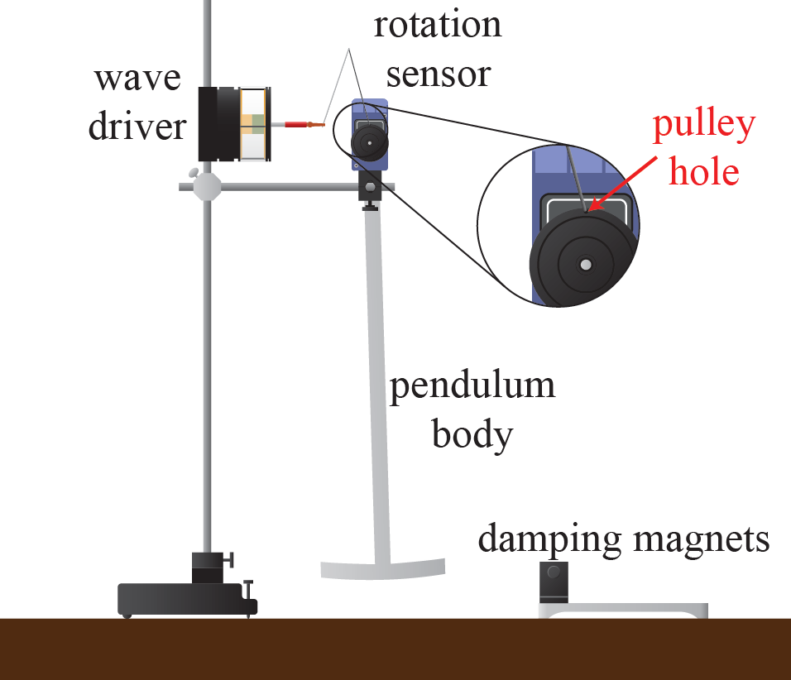

Figure 1: Physical Pendulum with Wave Driver Setup. Figure reproduced with permission from Fig. 6.1 by Campbell, W. C. et at1. As shown, the pendulum body was suspended from the rotatable rotation sensor. The wave driver was set up perpendicular to the pendulum body so that, when driving was needed, the wave driver would drive the rotation sensor’s motion by pushing the metal wire attached to it and the pulley hole on the rotation sensor. The wire was bent as shown in the figure. When damping as necessary, the damping magnets were placed at the center of the “T” of the pendulum and the pendulum only raised to the extent that the pendulum would always be between the magnets during every part of the motion. A photogate was also set up (not pictured) to the right of the pendulum to mark this spot of how high the pendulum should be raised so that consistency was maintained for each trial. The pendulum body was raised to the right so it was just barely blocking the photogate sensor for each trial.

First, the physical pendulum system was set up as shown in Figure 1, with the wave driver (with its wire spring) and damping magnets in place. Once everything was setup, the rotation sensor was zeroed with the pendulum body at equilibrium and the sampling rate was set to 40Hz.

For this part of the experiment, the damping magnets were centered right at the “T” of the pendulum body. A photogate was set up to the right of the pendulum so that the pendulum could be raised to the same for each trial, which avoids any systematic error as a result of the initial conditions. The damping magnets were adjusted so that they were 50mm apart with the center of the pendulum head centered between them. The pendulum was then pulled the the right to the height marked by the position where it would just unblock the photogate as it started its motion and the rotation sensor’s readings were recorded for the motion for about 20 seconds. This was then repeated for magnet spacing of 40mm, 30mm, 20mm, and 10mm. Another trial was then conducted without damping, meaning the magnets were removed entirely. The rotation sensor was zeroed between each trial so that the data could be directly compared. During these trials, The motion was visually observed to see at what spacing the motion would approximately critically damped, and from this estimation, 1mm increments were taken in the spacing to find the maximum magnet spacing (i.e. the minimum damping) such that the angular velocity does not change sign. This spacing was found to be the spacing needed to achieve critical damping.

Then, the magnets were moved back to a 35mm spacing. This is the spacing at which the undriven motion would damp out in about 10 seconds. The wave driver was then turned on and set up to produce a sinusoidal driving torque on the physical pendulum with a drive voltage of 5V. Then, in order to find the driven, damped oscillator resonance, Lissajous figures were generated by plotting the angle vs the drive voltage. The exact driven, damped oscillator resonance was found by finding the drive frequency at which the parametric plot was a perfect circle. This resonance was also found using the maximum amplitude method. Over ten drive frequencies around the estimated resonance were tested, and the amplitudes plotted, the drive frequency with the highest amplitude being the one that produces resonance.

Part II: Waves on a String

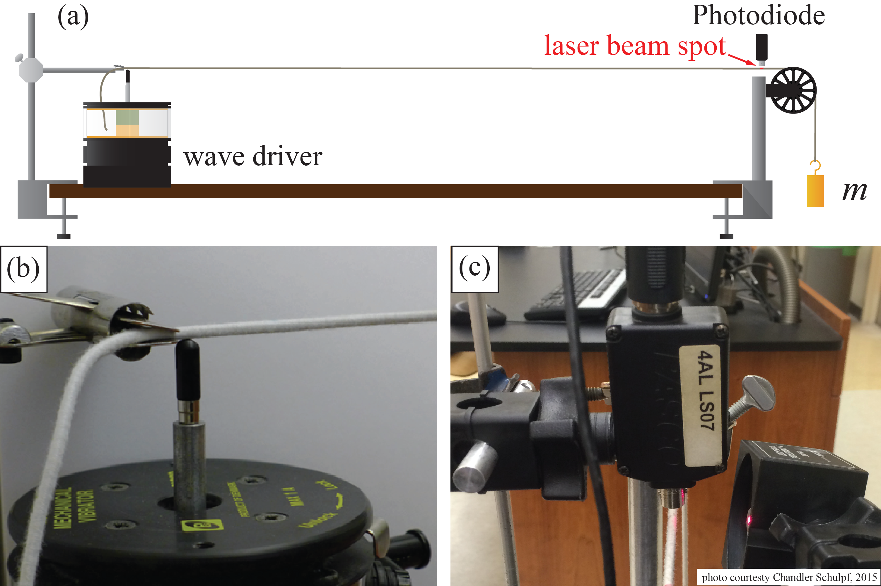

Figure 2: Driven String and Hanging Mass System Setup. Figure reproduced with permission from Fig. 7.1 by Campbell, W. C. et at1. As shown, the system is set up by creating tension in a ~1 meter elastic string by hanging a mass attached to it over a pulley. At the other end, the string is attached to a metal clamp, and 2mm from the clamp the wave driver is placed so that the string lies just on top of the actuator. On the other end of the string, just before the pulley, about 8mm from the pulley head, a laser is set up from the side so it covers the top third of the string. Then, from above, a photosensor is set up so that it can detect the light scattered by the laser-string system as vibrations occur.

First, a string was obtained, and its mass and length measured. Then, the string with mass was set up so that it had a tension proportional to a mass, *m*, suspended from a pulley as shown in Figure 2. A wave driver was set up to drive this motion. In order to quantify and analyze these driven vibrations, a photodiode was set up about 8mm from the pulley apex to record the amount of light scattered by a laser beam pointed at the end of the string. In order to avoid systematic error, the actuator tip was set up so that it just touched the string on its left-most boundary, about 2mm away from the clamp. In order to minimize the systematic error of outside light being detected by the photodetector, the head of the photodetector was faced as close as possible to the string right above the laser beam spot without it actually touching the string as it vibrated. Various lengths and positioning’s were adjusted by millimeters to ensure that a basic system response was sinusoidal. The length of the string actually being stretched (i.e the distance from the clamp to the pulley apex) was then recorded.

Then, the wave speeds for the waves on the string were found for various tension levels by varying the mass, *m*, suspended from the pulley and using the formula . Where T is the tension in the string and is the linear mass density of the stretched portion of the string. First, a mass of 150g was suspended, then 300g, and finally 400g (all with an uncertainty of .01g). For each mass, the system was allowed to settle into equilibrium and then the length from the pulley apex to the knot supporting the mass suspended was measured. The more mass was added, the larger this value became. The wave driver was then turned on to 0.2 Hz, and the amplitude set to 1 V. The photodiode output was then recorded for the oscillating string for about 10 seconds, the pattern created here to be saved for later analysis to find the experimental wave speed. This was done for each of the three trials.

Then, for the next part of the experiment, the 400g weight was left on so that the string was pulled taught. The string was plucked in the center and the resonant frequency was very roughly estimated to get a starting point for the first frequency to try. The actual resonant frequency of the fundamental node was then found by moving this number up and down until the string was observed to be vibrating violently with no nodes and the amplitude of the photodiode signal was maximized. This resonant frequency was then found again using the Lissajous figure method. Using the Lissajous figures and the equation , the resonant frequencies of higher-order nodes (up to n=9) were found. In this equation, *L* is the length from the metal clamp to the pulley apex, *n* is the number of normal modes, and *v* is the wave speed.

**ANALYSIS**

**Damping Regimes and Wave Speed**

Figure 3. The Three Regimes of Damping. The blue dotted sinusoidal curve shows the angle change over time for 50mm magnet spacing, this is the underdamped case. The orange dotted curve is the critically damped case, where the magnet spacing is 14mm. The grey dotted line is the overdamped case, where the magnet spacing is 10mm. The critically damped case clearly converges to zero faster than the overdamped case, as expected.

The three regimes of damping are shown in Figure 3. The underdamped case changes sign in a sinusoidal pattern as shown. The overdamped case converges to zero without changing sign, and the critically damped case also converges to zero without changing sign but does so slightly faster than the overdamped case.

The wave speed, *v,* of the undamped motion can be calculated using the formula relation , where *T* is the tension in the string and is the linear mass density of the stretched portion of the string. T, the force of tension in the string can be found using the equation , where *M* is the mass of the string, m is the mass of the weight suspended, and *g* is the acceleration due to gravity. Using this equation and the definition of the linear mass density (the mass divided by the length) the complete equation for the wave speed, *v*, was found to be:

The actual calculated values for the linear mass densities and wave speeds for each trial are shown in Table 1, this speed is calculated using values from the undamped trial.

Finding the Quality Factor-Method 1:

Figure 4. Damping Time with 35mm Spacing. The blue dotted line above depicts the motion over time for the physical pendulum with a 35mm gap between the damping magnets. As shown, there is a significant decay in amplitude over time, the oscillations almost completely dying out after 15 seconds. The damping time can be found by analyzing how much the amplitude decays over time, which is examined in Figure 5.

Figure 5. Peak-Height Ratios for 35mm Spaced Damping. The blue dots show the peak height ratios for six amplitudes. The motion mas mostly died out after these six, which limits the accuracy of the analysis. However, from the blue dotted trend line we can see the results are fairly parallel to the x-axis, as desired. In fact, the trend line is of the form y=ax+b where a=-0.006±.004 and b=0.70± .01. The very small slope allows us to conclude that there is a trend in these amplitude ratios, and we can therefore use these amplitudes in our damping time analysis.

To find the damping time for the oscillation, we average the damping time for each ratio of successive normalized peaks. The damping time for one ratio is:

Where is the angle at time t, T is the period, which is 1.41±.05 s. is the angle one period away from t, and is the damping time. This equation can be solved for to get:

Using this equation, the damping time for each ratio was found and then averaged to get a value of 3.62±.05 s for . Using and the we found using the Lissajous Plots in Figure 6, Q, the quality factor, can now be calculated using the equation . From this method, Q is found to be 1.39±.07.

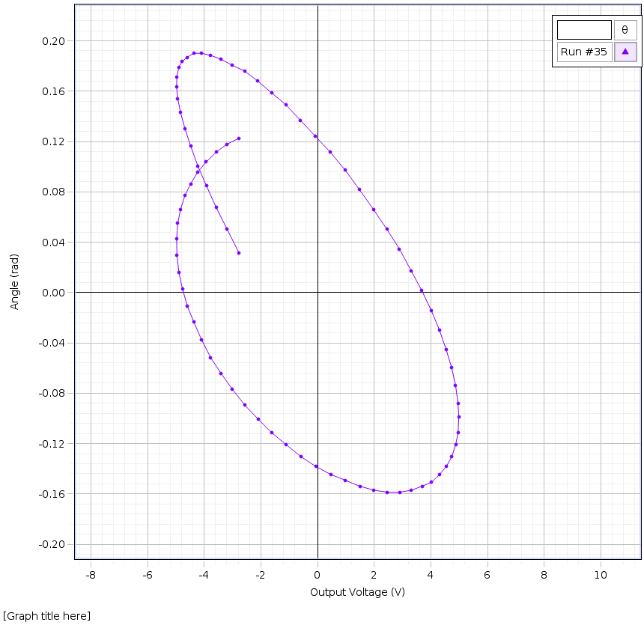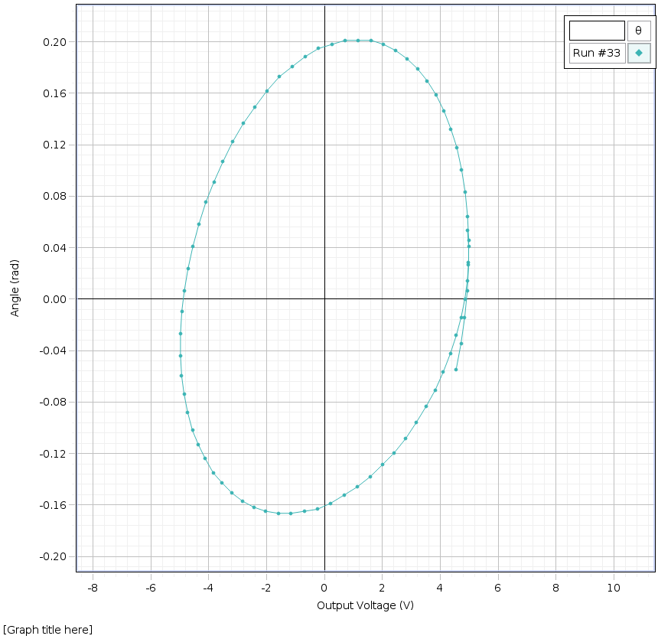

**b)**

**a)**

**c)**

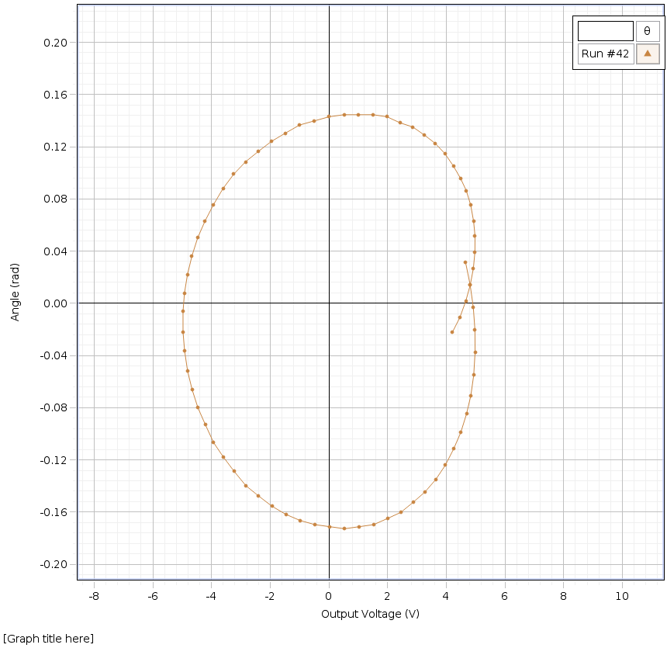

Figure 6. Lissajous Figures to Find the Resonant Frequency Figure a) shows the figure obtained with a driving frequency of Hz. This graph is not an untilted circle since it leans toward the right. This right-leaning implies that the driving frequency is less than the resonant frequency. Figure b) shows the figure obtained with a driving frequency of Hz. This graph is not an untilted circle since it leans toward the left. This left-leaning implies that the driving frequency is greater than the resonant frequency. Figure c) shows the figure obtained with a driving frequency of Hz. This graph is an untilted circle. This symmetry implies that the driving frequency is equal to the resonant frequency. Therefore = Hz.

Finding the Quality Factor-Method 2:

Figure 7. Amplitude Response to Drive Frequency The blue scatterplot shows the oscillation amplitudes in radians with respect to the applied driving frequency. The curve has a peak at approximately 0.73 Hz, this number was found by averaging the two top data point’s drive frequencies. This number should correspond to the resonant frequency. This does not perfectly align with our earlier found value for the resonant frequency, = Hz. However, the numbers are almost within each other’s uncertainties.

Q can also be found by examining the amplitude response at the various driving frequencies as shown in Figure 7. By finding the frequencies that correspond to the amplitudes that are of the peak height in Figure 7 subtracting them from each other and multiplying by 2, can be found. The peak height is 0.0157 rad. The frequencies that correspond to of the peak height are 0.625 Hz and 0.775 Hz. Therefore 0.942 Hz. Using the equation , Q is found to be 5.12 ± .5 . The error was estimated based on how the frequencies were found by averaging data points and the width of the peak. This value is not within range of the Q found using method 1. Method 2 is a much less accurate way of finding Q since there is so much uncertainty because only about 10 drive frequencies were measured to find their amplitudes. To get an accurate reading for Q using this method, many more data points would be needed and also a higher sample rate. Therefore, Method 1 was deemed the more accurate and valid method.

Wave Speed of the Waves on a String-Method 1

|  |  |  |  |  |  |  |
| --- | --- | --- | --- | --- | --- | --- |
| Mass Suspended  *m* (kg) | Mass of the String, M (kg) | Length of the Stretched String,  L (m) | Percent of String Suspended (%) | Force of Tension, T (N) | Linear Mass Density, (kg/m) | Wave Speed,  *v* (m/s) |
| 0.150 | 0.017 | 2.445 | 0.178 | 1.500.01 | 0.007 | 14.60.3 |
| 0.300 | 0.017 | 2.493 | 0.194 | 2.970.01 | 0.007 | 20.60.4 |
| 0.400 | 0.017 | 2.551 | 0.212 | 3.950.01 | 0.007 | 23.80.6 |

Table 1. Predicted Wave Speed Calculation The masses all have a shared systematic uncertainty of 0.001kg since they were measured using the same scale. The length of the string has an uncertainty of 0.001m. The tensions were calculated using the equation T = g(m+M) where m is the mass of the string suspended and M is the mass of the weight suspended. This must be done because the string has mass. In this situation, the pulley is assumed to be massless. The wave speeds were then calculated using the equations as described below.

In Table 1, the linear mass densities, , were found using the equation ,. and the wave speeds, *v*, were found using the equation where the tension, *T = g(m+M).* Note that the wave speeds increaseas the tension increases, as expected.

Wave Speed of the Waves on a String-Method 2

The wave speed can also be calculated from experimental data using the photodiode signal vs time to find the time lapse between peaks in the light intensity. This, in conjunction with the fact that in this time period the wave will have traveled twice the length of the string from the pulley to the clamp, allows us to derive and solve the equation for the wave speed, :

Where is the length from the pulley to the clamp, and is the time lapse in the light intensity peaks seen in Figures 8, 9 and 10.

Figure 8. Light Intensity Signal Response Pattern with 0.150 kg Mass Suspension The blue scatterplot with smooth connecting lines shows the clear pattern of the light intensity for the motion with the 0.150 kg mass suspended from the string. The data starts at t=3s for clarity since there is noise at the start of the motion. The upward spikes indicate that a pulse has gone down and back up the string, meaning the pulse has traveled the pulley to clamp distance twice. The distance between the upward spikes, T is found here to be 0.26.01 s. This uncertainty was assigned based on the average width of the peaks.

Figure 9. Light Intensity Signal Response Pattern with 0.300 kg Mass Suspension The orange scatterplot with smooth connecting lines shows the clear pattern of the light intensity for the motion with the 0.300 kg mass suspended from the string. The data starts at t=4.5s for clarity since there is noise at the start of the motion. The downward spikes indicate that a pulse has gone down and back up the string, meaning the pulse has traveled the pulley to clamp distance twice. The distance between the downward spikes, T is found here to be 0.19.01 s. This uncertainty was assigned based on the average width of the peaks.

Figure 10. Light Intensity Signal Response Pattern with 0.400 kg Mass Suspension The orange scatterplot with smooth connecting lines shows the clear pattern of the light intensity for the motion with the 0.400 kg mass suspended from the string. The data starts at t=3.5s for clarity since there is noise at the start of the motion. The upward spikes indicate that a pulse has gone down and back up the string, meaning the pulse has traveled the pulley to clamp distance twice. The distance between the upward spikes, T is found here to be 0.16.01 s. This uncertainty was assigned based on the average width of the peaks.

|  |  |  |  |
| --- | --- | --- | --- |
| Mass Suspended  *m* (kg) | Length from Clamp to Pulley, LCP (m) | Time delay, T (s) | Wave Speed,  *v* (m/s) |
| 0.150 | 2.010 | 0.26.01 | 15.46.03 |
| 0.300 | 2.010 | 0.19.01 | 21.44.06 |
| 0.400 | 2.010 | 0.16.01 | 24.97.07 |

Table 2. Calculating the Wave Speed Experimentally The time delays, T, were found using Figures 8, 9, and 10. The time difference from peak to peak in the light intensity for each mass suspended is what made up these values. The uncertainties were assigned based on the width of each respective peak. The mass suspended had a systematic uncertainty of 0.001kg and the length from clamp to pulley had a systematic uncertainty of 0.001m. there uncertainties were caused by and assigned based on the measurement devices used to gather the data. The wave speeds were calculated using the equation derived earlier, *.*

Frequencies from n=1 to n=9

|  |  |  |
| --- | --- | --- |
| Mass Suspended, *m* (kg) | Fundamental Frequency from Method 1,  *f* 1 (Hz) | Fundamental Frequency from Method 2, *f* 2 (Hz) |
| 0.150 | 3.632.007 | 3.845.001 |
| 0.300 | 5.124.009 | 5.333.002 |
| 0.400 | 5.92.01 | 6.211.002 |

Table 3. Calculation of the Fundamental Frequency Using Both Methods Using the equation , the fundamental frequencies were calculated as above. Since this is the fundamental frequency, n here equals 1. L is the length of the string from the clamp to the pulley, and v is the wave speed, either from Method 1 (Table 1) in column 2, or from Method 2 (Table 2) in column 3.

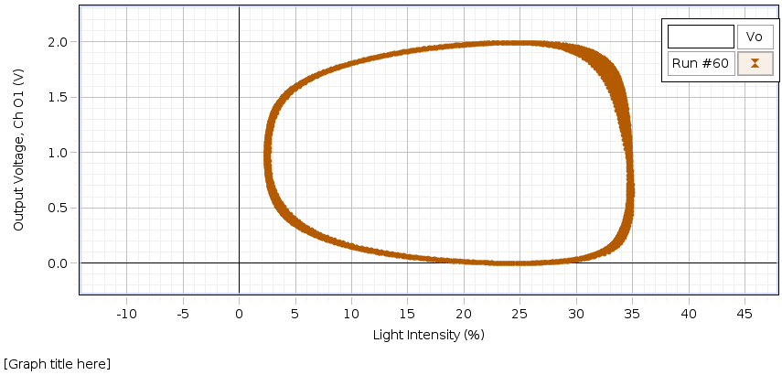

Figure 11. Symmetry of Lissajous Plot at 6.375 Hz This Lissajous plot was used to determine that 6.375.001 Hz is the resonant frequency for n=1. Many plots were made, above and below this value, and this one was deemed the most symmetric, which implies it is the correct value. The uncertainty was assigned based on how much the frequency could be moved up and down without any discernable difference in the symmetry.

Using the maximum-amplitude method the resonant frequency for the first fundamental n=1 was found to be 6.375.001 Hz. This uncertainty was assigned based on how much the frequency could be moved up or down and an amplitude difference not be distinguishable. Then using Lissajous figures, and finding the frequency corresponding to the most symmetrical plot (the on shown in Figure 11), the resonant frequency for the first fundamental was found to be 6.345.001 Hz. Again, this uncertainty was assigned based on how much the frequency could be shifted without and discernible change in the Lissajous figure.

|  |  |  |  |  |  |  |  |  |
| --- | --- | --- | --- | --- | --- | --- | --- | --- |
|  | n=2 (Hz) | n=3 (Hz) | n=4 (Hz) | n=5 (Hz) | n=6 (Hz) | n=7 (Hz) | n=8 (Hz) | n=9 (Hz) |
| Max. Amp. Method | 12.75.02 | 19.12.03 | 25.5.04 | 31.87.05 | 38.25.06 | 44.62.07 | 51.00.08 | 57.37.09 |
| Lissajous Method | 12.69.001 | 19.035.01 | 25.38.001 | 31.725.001 | 38.07.001 | 44.415.001 | 50.76.001 | 57.105.001 |

Table 4. Frequencies for Nodes up to n=9 for Both Methods Using the same methodologies as for the fundamental frequency as described in Table 3, the resonant frequencies were found to be as shown above. These frequencies were close to each other’s uncertainties which implies that they both good methods to use. However, given that the Lissajous method had a lower uncertainty than the Maximum Amplitude method, the Lissajous figure method was found to be the better method.

As shown in Table 4, though the found frequencies are almost within each other’s uncertainties, they just barely miss the mark. These discrepancies are likely due to various systematic sources of errors associated with each method, which will be discussed in more details later.

**CONCLUSIONS**

In this experiment, mathematically derived outcomes were compared with experimental outcomes for resonant frequency, wave speed and quality factor calculations of a physical pendulum and vibrating string in order to determine the validity and accuracy of these results. Using the mathematically derived method, Q was found to be 1.39±.07, and using the experimental value, Q was found to be 5.12 ± .5These values are not within each other’s uncertainties and the percent error here is very high. Because of this, the results of method 2 were deemed imprecise. This is likely due to the sources of error present in the experimental calculation. For a 0.400kg mass suspension, using the mathematically derived method, the wave speed, *v*, was found to be 23.80.6 m/s, and, using the experimental value, *v* was found to be 24.97.07 m/s. These values are almost within each other’s uncertainties, but miss each other by .5 m/s. These values are reasonably close, but their discrepancies raise flags about the validity of the experimental values found in method 2, since these are the value with a higher degree of uncertainty since there are more sources of error present in an experimental calculation. For a 0.400kg mass suspension, using the mathematically derived method, the fundamental frequency was found to be 5.92.01 Hz, and, using the experimental value,the fundamental frequency was found to be 6.211.002 Hz. These values are clearly not within each other’s uncertainties, and this is excepted as the sources of error present in the wave speed calculation would also be present in the frequency calculations. Clearly, in all of these three calculations sources of error were present in the experimental method values. This is likely due to the fairly rudimentary set up of the experiment. One source of error present was the length of the string, the stretched portion of the string was only 2.01m long, which made observing nodes up to n=9 difficult. One way to alleviate this source of error would be to use a longer string. Another source of error was the shifting of the equipment. The experiment took place over the course of many hours, and equipment shifts were carefully avoided but likely occurred to some degree. For example, during the stretched spring portion of the experiment, the stand keeping the clamp in place slipped several times and had to be repositioned using a piece of tape used to mark its spot. In addition, during the pendulum part of the experiment, the damping magnets had to be removed and repositioned between each trial so that the spacing could be adjusted and measured. These sources of error could be alleviated by using more precise and better equipment such as a heavier stand or magnets that don’t need to be moved to be measured. Even though there were clear sources of errors present as evidenced by the discrepancies between the experimental and mathematically predicted values, the experiment was still valid in that it showed that the experimental results had at least some correlation to the predicted results. As a result, the experimental values were deemed usable only as rough estimates rather than precise values.

Bibliography:

1. Campbell, W. C. *et al*. Physics 4AL: Mechanics Lab Manual (ver. August 31, 2017). (Univ. California Los Angeles, Los Angeles, California).